Community-informed reformulation project: community research brief

Context

Lambeth and Southwark have diverse populations, yet local convenience stores and larger retailers do not typically provide healthy and affordable culturally appropriate food. We have found that many local families instead travel to visit specialist stores for such products. In addition, culturally appropriate foods are often left out of mainstream reformulation efforts.

As a result, we are launching an exciting new project that seeks to take a community-led approach to reformulating food and drink products with small-medium manufacturers, to be healthier and yet still affordable.

To note, food reformulation is defined as the process of altering the ingredients and/or process of producing a food or drink product, to improve its nutritional profile (for example increasing the quantity of fibre) or to reduce its content of ingredients or nutrients that are of concern (for example reducing the amount of sugar or calories).

This project aims to reduce the racial inequalities within our local food economy, by seeking to demonstrate that culturally appropriate food can be reformulated to be healthier and affordable. The targets, Theory of Change and Logic Model for this are included as an appendix at the end of this document.

Overview and aim of the community research within this project
We want to understand what food and drink products families and young people are regularly buying from local convenience stores, their perceptions of how healthy these products are and what products they would most like to see reformulated to be healthier.

We then want to work with the manufacturers to reformulate the community-selected products to make them healthier and tailored to local community preferences.

We are recruiting a community partner to lead on the research and engagement with families in Lambeth and Southwark. The community research will be combined with local market research and engagement with manufacturers to inform the reformulation process. The project group is committed to ensuring that the reformulated products remain affordable for local families.

The community partner’s role is to lead on the community research stage and remain involved throughout the project. This is to ensure that the engagement with manufacturers/SME food businesses and the reformulation of the products meets the needs and aspirations of local communities.

The project team

The project lead will be EIT Food. EIT Food is Europe’s leading food innovation initiative, working to make the food system more sustainable, healthy, and trusted by consumers. EIT Food is a member organisation bringing together key industry players, agrifood startups, research centres and universities representing the food value chain in Europe. The project team is made up of a Programme Manager, a food industry researcher, and industrial/manufacturing advisers.

Reading Scientific Services Ltd (RSSL) is a leading provider of testing, inspection and consultancy services across the food sector and will be leading on the reformulation phase of this project.

Impact on Urban Health is part of Guy’s and St Thomas’ Foundation, an independent charitable foundation based in South London. We’re committed to achieving health equity by helping urban areas become healthier places for everyone to live. We fund and partner with local, national and international organisations to tackle complex health issues more prevalent in urban areas, through our programmes – children’s health and food, financial foundations for adult health, the health effects of air pollution and children’s mental health.

We focus on children’s health and food because we believe all children should have the opportunity to be healthy, no matter where they live. We want to increase access to healthier, affordable and culturally appropriate food for families and young people, whilst reducing the availability of cheap unhealthy food options within our high streets.

The successful community research partner will be contracted by Impact on Urban Health, with a Memorandum of Understanding (MoU) between the community research partner, Impact on Urban Health and EIT Food setting out how the three organisations will work together for the duration of this project.

Outline of the community engagement

Ideally, this project will focus on families on low incomes and from racially minoritised backgrounds, who regularly shop at convenience stores. We would like 40 to 60 families to be part of the community engagement (with some engagement to include their children and young people too).

The community research partner will play an important role in ensuring that families’ preferences and views are included in the reformulation process, and that the community insights are used in a meaningful way to directly inform the reformulation product brief. The research partner will also need to help manage expectations, should the identified manufacturers/product not wish to engage in the reformulation process. The research partner and the wider project team will need to keep families updated and share the results at the end of the project (late summer 2026).

Proposed approach

It is up to the research partner to identify the best methods of engaging with families and children, that meets the preferences of local families. This could include interviews, focus groups, surveys, etc. Engagement plans should ideally be developed with families.

Key questions to be answered by the families to inform the product reformulation briefs:

- Which products would you like to eat more of?
- Which products would you like to eat less of?
- What stops you from eating this product more regularly? (based on responses to question 1)
- Would you eat it more regularly if it was lower in calories/salt/sugar/fat? (based on response to the question above)
- Which nutrients would you like to see more of in this product (e.g. protein, fibre, vitamins and minerals)?
- Are there other products that you would choose as a healthier option in place of this product?
- Would you be willing to pay more if this product was lower in calories/salt/sugar/fat? If yes, how much more would you be willing to pay?
- Would you be willing to pay more if this product was higher in protein/fibre/vitamins and minerals? If yes, how much more would you be willing to pay?
- If this product was reformulated, what would you like to be taken into consideration or change about the product?
- Would you expect the reformulated product to taste the same as the current product?

Timescales and key deliverables

The project will run for 18 months (until summer 2026). There is some flexibility to the following timescales, and they can be tailored to best engage with local communities:

- April & May 2025: Planning and initial engagement with families and help the project team set the learning questions for this work
- June to August 2025: Engagement with families – contemporaneous write up of needs/wants
- From July 2025: EIT Food to work with community researchers’ information to identify manufacturers who produce the priority-identified foods
- July-August 2025: Community researchers work with the reformulation partner to develop product briefs tailored to the needs identified through the family engagement phase
- August 2025 to August 2026: Project partner RSSL conducts reformulation work with food manufacturers/producers (8 products anticipated)
- September 2026: With the project team, share results with participating families.

The key deliverables for the research partner will include:

- A detailed engagement plan, to be agreed with IoUH and EIT Food (approximately by the end of April 2025)
- A summary and write up of the key themes, food categories and products identified through the community engagement, as programme develops.
- Ongoing engagement and participation in project group meetings throughout the eighteen months.

Frequency of project group meetings:

- One kick off meeting at the beginning (online)
- Monthly catch ups (online)
- Three in person interim meetings (at 6 months, 12 months and 15 months)
- One in person wrap up meeting (at 18 months)

Additional calls and meetings can take place if and when necessary.

The community research partner will need to renumerate participating families for their time and any expenses. This is to be factored into the budget plan, along with covering any venue hire and resources needed to carry out meaningful community engagement.

What we are looking for

- Experience of working closely with community groups and families in Lambeth and/or Southwark
- Experience of carrying out community research with local families and a commitment to ensuring that the families are kept up to date with the project and involved with the project where possible, throughout the course of the 18months
- A commitment to work closely with the project team and a range of different stakeholders.

It is not essential to have detailed knowledge of food nutrition, reformulation or food and drink marketing – the project team will be able to support with this to ensure meaningful conversations with families is possible.

EIT Food’s team includes an impact specialist who will be available to help with the successful organisation in developing the work, based on the Theory of Change and Logic Model (at the end of this document).

Budget

The overall budget envelope for this research piece is £65,000, including VAT. This is inclusive of any venue costs required to carry out the community engagement and to reimburse participating families for their time and any travel expenses incurred.

There is the potential for this project to be expanded or extended beyond September 2026. Any plans will be discussed in advance with the community research partner to explore future capacity and budgets. This further phase would include the reintroduction of the reformulated products back into the market.

How to apply

Proposals are to be a maximum of 2 pages long.

We equally welcome individual organisations, freelancers, or partnerships of consortia to apply.

To apply, please send your proposal to Becky Steele, Portfolio Manager: becky.steele@urbanhealth.org.uk by 6pm on Friday 21st March.

We will then invite shortlisted applicants for a 30-minute online interview on Thursday 27th March to explore their proposals in more depth (with some flexibility if Thursday 27th is not possible).

Your proposal should include the following:

- Details of your organisation(s), and details of any relevant experience, skills and knowledge of your team – we will be looking for teams with the specific experience and expertise outlined in the brief.
- Your proposed approach for responding to this brief and aims of the research project – we will be looking for proposals that reflect the key elements and principles of the approach we have set out above and that provide a creative and appropriate methodology to answer the key research questions.
- Your project management and quality assurance arrangements.
- How you will comply with good ethnical practice – how you will ensure that participants are aware of what information you are collecting and for what purpose, how you will deal with confidentiality, how you will ensure participants can give informed consent and are not harmed, how you will comply with data protection legislation and ensure participants are reimbursed for their time and any expenses.
- A clear breakdown of indicative costs (including number of days) to deliver your proposal.

Application timeline

- Deadline for applications: 6pm Friday 21st March
- Interviews for shortlisted applicants: Thursday 27th March
- Kick-off: April 2025

Please address any questions to Becky Steele at becky.steele@urbanhealth.org.uk

  - Appendix A: Targets

Measurable Indicators | Target | Impact Goals
- # participants in consumer surveys  - # reformulated products  - # SMEs supported  - # community events  - Change in nutritional profile (Quantitative change of nutrients (e.g., sugar decreased 30%) / Quantitative change of product (e.g., calories/ nutrient density, portion size) / Category change (e.g., sugar moved from ‘high’ to ‘medium’ category based on UK Traffic Light System) / Category Change e.g., product moved to score of less than 4 / ‘healthy’ based on UK Nutrient Profile Model/ # or % of products that are now non-HFSS)  - Change in ingredient costs (Quantitative change of cost (e.g., ingredient cost decreased 2%) or Goal range of cost (e.g., ingredient cost rose no more than 5%)  - Change in retail pricing (Quantitative change in price (e.g., price rose 2%) or Goal change vs market leader (e.g., price no more than 10% above)) | - 40-60 local families take part  - 8-10 reformulated products  - 2-6 SMEs  - 2 community events  - TARGETS on nutritional profile: suggested >5% improvements as minimum  - Cost savings or equal to current supplier burden  - RRP within 5% of current price | - Improved access to affordable, healthy, and culturally diverse food  - Improved wellbeing and health  - Improved food security  - Improved food entrepreneurship

Appendix B: Theory of Change

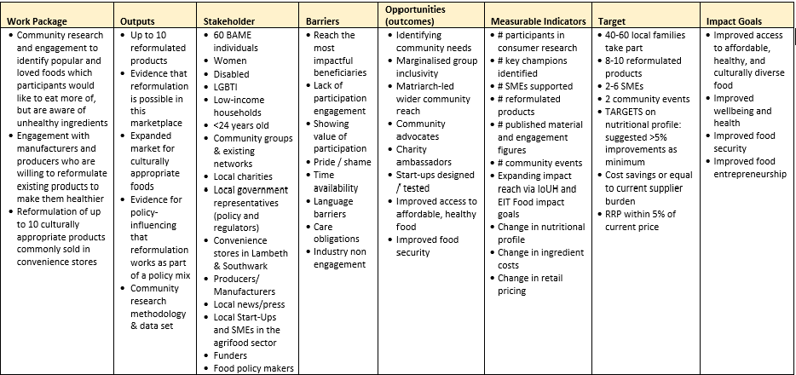

Appendix C: Logic model

